Haxby and Wigginton Cemetery Committee

Acting as Burial Authority for the Parishes of
Haxby and Wigginton.

Haxby and Wigginton Cemetery
Moor Lane, Haxby, York YO32 2QN

Rules and Regulations

Haxby Town Council Office, The Memorial Hall
The Village, Haxby, York YO32 3HT
Tel: 01904 750378

March 2022

Haxby and Wigginton Cemetery Committee

The grave spaces in the Cemetery can be purchased or reserved by current residents of Haxby and Wigginton.

Non-residents who have previously reserved a grave will still be eligible but will be subject to double interment fee.

At the discretion of the Cemetery Committee the cremated remains of non-residents can be interred into graves of a spouse, partner, parent or sibling providing there is space, and will be subject to double interment fee.

All other requests with supporting documentation must be brought to a meeting of the Cemetery Committee where a decision will be made.

- The cemetery will be open from 08:30 till dusk. There is a car park provided in the new section of the Cemetery. When visiting, please give consideration to neighbours by driving in through either the Moor Lane or the Oaken Grove entrance and parking inside. Please close the gates when you leave. The gate at Oaken Grove allows disabled access.

2. Notice of interment is to be given to the Clerk of Haxby Town Council (01904 750378) between the hours of 09:30 and 12:00, Monday to Friday, at least 48 hours notice (exclusive of weekends) previous to any interment, except in special cases. No application can be received at Weekends or Bank Holidays, except in an emergency.

- The notice should contain: - Full Forename(s), Surname, Address, Age, Date and Place of death of the person to be buried. The proposed date and time of burial and grave number if already purchased. If a second grave space is to be reserved, name address of person requiring it to be provided.

- All graves are single depth except in Plot 19 and Plot 30 where the cremated remains are double depth for caskets. There is also a Garden of Remembrance which is a non-consecrated area for cremated remains.

- No burial can take place before 09:00 or after sunset without special permission. No burial can take place on a Sunday. The time named for the funeral is when the cortege is due to arrive at the Cemetery, and it is important that the time is kept.

- All fees and charges due are to be made payable to Haxby and Wigginton Cemetery Committee and paid to the Clerk to the Cemetery Committee. Current charges are available from the Council Office (01904 750378). In all cases where a grave has been purchased or where permission is granted by the Cemetery Committee for interment of a non parishioner double fees will be charged. The receipt for payments and the Registrar’s Certificate of Burial must be produced on the day of the funeral at the Cemetery.

- The selection of the grave site, in all cases, is subject to approval of the Cemetery Committee.

- Graves reserved by parishioners may not be transferred to any other person without the consent of the Cemetery Committee.

- Graves no longer required by parishioners may be sold back to the Cemetery Committee for the original purchase price less a £25 administration charge.

- Graves are to be dug only by a person approved by the Cemetery Committee.

- Every purchased grave, with the headstone, must be kept level, in good order and repair by the owner without obstruction to grass cutting. Any items causing obstruction will be removed. No trees, plants or shrubs shall be planted on grave spaces. Vases of flowers may be placed on grave spaces but as close to the headstone as possible.

- The Cemetery Committee will undertake the maintenance of the Cemetery, to include cutting and trimming the grass on and around the grave, and keeping it clean and tidy. Any items which are considered to be obstructing grass cutting will be removed.

- No person, other than the owner or relation of the owner or relations of the owner of the deceased person shall, without consent of the Cemetery Committee, be permitted to carry out maintenance of any grave.

- All materials and headstones must be conveyed into the Cemetery by hand or on rubber tyre vehicles and the same applies to the removal of soil and refuse from the Cemetery.

- No dogs, except Assistance Dogs, are allowed in the Cemetery.

  - All Monuments, headstones or plaques proposed to be erected in the Cemetery, and the proposed inscriptions, are subject to the approval of the Cemetery Committee.

  - A drawing showing the form and dimensions of every memorial proposed to be erected and a copy of every inscription must be sent to the Clerk to the Cemetery Committee for approval. Inscriptions to be on the front of the headstone only. The maximum sizes for memorials are as follows:

- Headstone for a single grave 32” high (815mm) x 27” wide (685mm) x 4” deep (102mm).
- Base for above 4” high (102mm) x 33” wide (840mm) x 12” deep (35mm).
- Headstone between two graves 32” high (815mm) x 32” (815mm) wide x 4” deep (102mm).
- Base for above 4” high (102mm) x 60” wide (175mm) x 18” deep (460mm).
- Memorial plaque for cremated remains 4” high (102mm) x 18” square (460mm).
- Memorial plaque for cremated remains in Garden of Remembrance 6” high(150mm) x 8” wide (200mm)

  - All headstones must be fitted with a safety anchor to NAMM standard. All memorial headstones and plaques are the responsibility of the owners and are kept in good repair.

  - A register of the burials is kept under the supervision of the Cemetery Committee and at all reasonable times searches may be made and certified extracts obtained upon application to the Clerk of the Cemetery Committee on payment of the appropriate fee.

- No person shall destroy or injure any building, wall gate or fence belonging to the Cemetery.
No person shall pull up, destroy or injure any tree plant or flower, or disfigure any wall, or put up any bill on any wall.
No Person will destroy, injure or deface any statue, monument, inscription, headstone or plaque, or so do any wilful damage, or play any game, or sport in the Cemetery.
No person will discharge firearms (except at a military funeral and authorised pest control) in the Cemetery.
No person to wilfully or unlawfully disturb any person or persons there for the purpose of interring any remains.

- The Cemetery Committee does not hold itself responsible or liable in any way for any damage which may be caused to monuments or any memorials which may be placed or erected in the cemetery.

- Although the Haxby and Wigginton Cemetery Committee do not encourage the donation of memorial seats in the Cemetery, relatives who wish to donate one should request permission from the Cemetery Committee. If the Cemetery Committee gives permission they will decide on the sighting, standard and design of the seat. It should be properly fixed into the ground and on a paved base. Supply and all installation costs are to be met by the donor. The seat will become the property of the Cemetery Committee who will maintain it or remove it for safety reasons, and keep the surrounding area clear of planting.

- In case any difficulty arises, which is not provided for by these regulations, it shall be referred to and settled by the Cemetery Committee, which reserves the right to make any alterations in the forgoing rules and regulations as it may be deemed necessary.

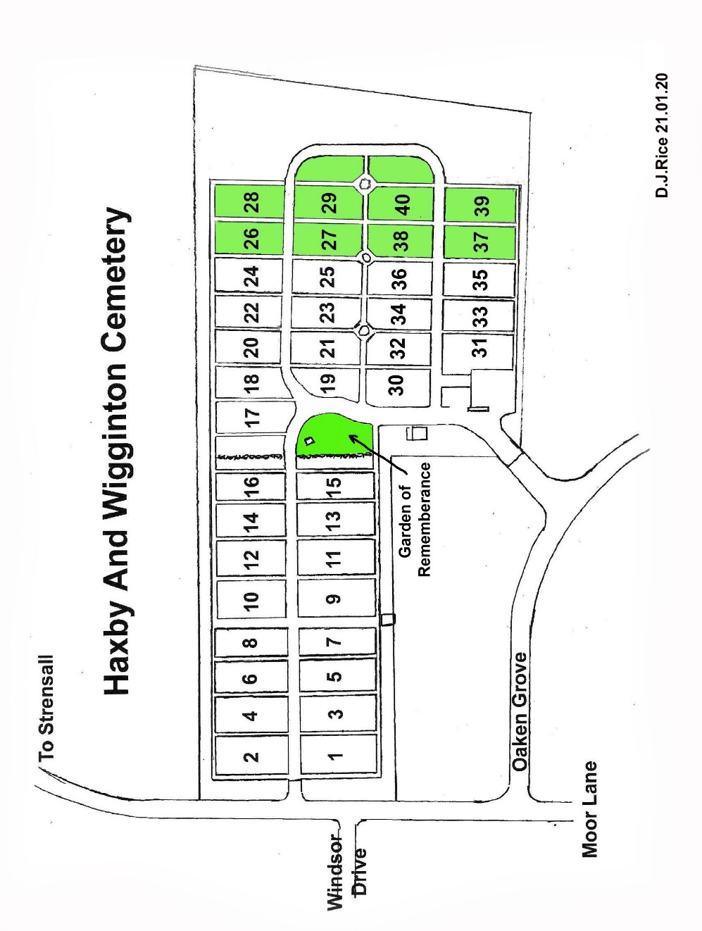

Burial Charges with effect from 1 April 2021

Purchase of Grave Space | £440*
Purchase of Cremated Remains Space | £305*
Interment | £285*
Interment of Cremated Remains | £140*
Interment of Cremated Remains in Garden of Remembrance (Non-consecrated area) | £295
Purchase of Space for Child under 12 | £140
Interment of Child under 12 | £140
Headstone | £140
Additional Inscription | £70

* In all cases where permission is granted by the Cemetery Committee for the purchase of a grave and for the interment of a non-parishioner double fees are to be charged.

