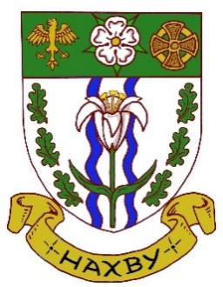
Haxby Town Council

Council Offices, Memorial Hall, The Village, Haxby YO32 3HT

JOB DESCRIPTION – STREET CLEANER / GROUNDSMAN

Overall Responsibilities

The Street Cleaner / Groundsman will be responsible for keeping the area of the town of Haxby clear of litter and working on the Ethel Ward Playing Fields in relation to the general maintenance and safety of the playing field and line marking of the football pitches.

The Street Cleaner / Groundsman role is part time (37 hours) per week, working 6 days on and 6 days off, with an alternating shift pattern with another Street Cleaner / Groundsman.

Specific Responsibilities

Street Cleaning

- Working in partnership with your fellow Street Cleaner / Groundsman.
- Each week and working together you will clean five routes, taking one route per day and working in the mornings.

Ethel Ward Playing Field

- Inspect the children’s play area and clear litter, broken glass, cans etc.
- Visually inspect the play equipment and swings, report any damage to the Clerk.
- Clear litter from the playing field.
- Inspect the pavilion inside and outside and sweep the paved area, replace any light bulbs as necessary.
- Sweep the netball courts and remove broken glass as necessary. Empty the bins as necessary.
- Mark out the football pitches and inspect the pitches when directed by the Clerk.
- Undertake various other jobs regarding the general maintenance and safety of the playing fields.
- Report any damage and health and safety issues to the Clerk

Mancroft

- Inspect the children’s play area and clear litter, broken glass, cans etc.
- Visually inspect the play equipment and swings, report any damage to the Clerk.
- Report any damage and health and safety issues to the Clerk

The Street Cleaner / Groundsman reports to the Clerk.

